Objectives:

* Writing and reading files.
* Try and catch the statement.
* Intro to GUI Interfaces.

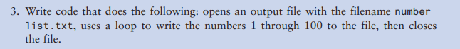

**#3 Print screen the output with the code below here**

**Submit this document to Module 3 homework.**